

**Software Development Project Management**

**Project Report**

**Developing the software development project management plan for Dhaka Subway Systems Automated Ticket Issuing System.**

**Section:** **B**

**Submitted to: S.M. ABDUR BHUIYAN ROUF**

**Date of Submission: 22-Dec-20**

**Submitted by:**

|  |  |  |
| --- | --- | --- |
| Serial No | Name | ID |
| 1 | Shebika Rani | 18-36839-1 |
| 2 | Humaira Khondokar Gim | 17-36006- 3 |
| 3 | Tania Rahman | 17-33841-1 |
| 4 | Mhmd. Mohaiminur Rahman |  |

$\underline{Abstract :}$ The objective & the purpose of this project is to design an “Dhaka Subway Systems Automated Ticket Issuing System” which will enables the passengers to search and book tickets for normal time journey and also in case for emergency time journey too. This report contains all the details of all the tasks carried out during the entire software development life cycle of the Ticket Issuing System Project. This document depicts all the details of the project.

$\underline{Introduction :}$ The main purpose of this vision document is to list the activity and the planning for the Dhaka Subway Systems Automated Ticket Issuing System project. This document helps us to collect and analyze the ideas gathered for the project that which activity / task has to be complete under how much time period. This document is mainly prepared to set stage for the completing the different part or phase of the project.

**Process Model:** Choosing an appropriate model for this software development decided to be the Waterfall model

**Why choose this Model-** the Waterfall model, also known as linear – sequential life cycle model. It is very simple to understand and use. In the waterfall model, each phase must be complete before the next phase can begin and there is no overlapping in the phases. The Waterfall model is the earliest SDLC approach that used for the software development.

Regardless, the concepts are all the same and encompass the broad scope of what it takes to start with an idea and develop a full-scale, live application.

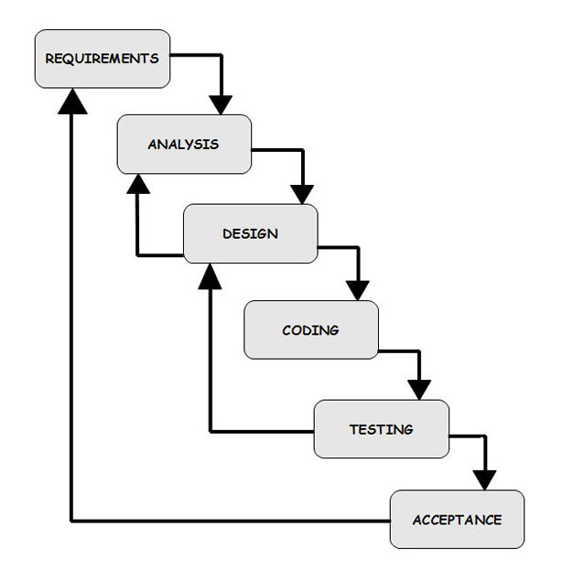

General overview of ‘Waterfall model’

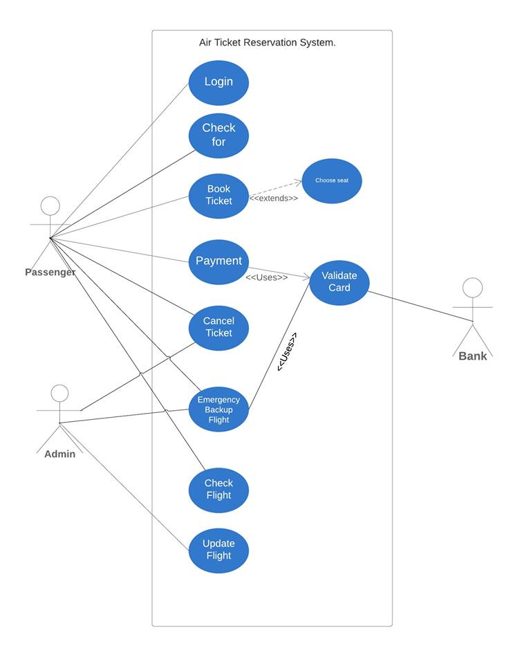

**Use Case Diagram**

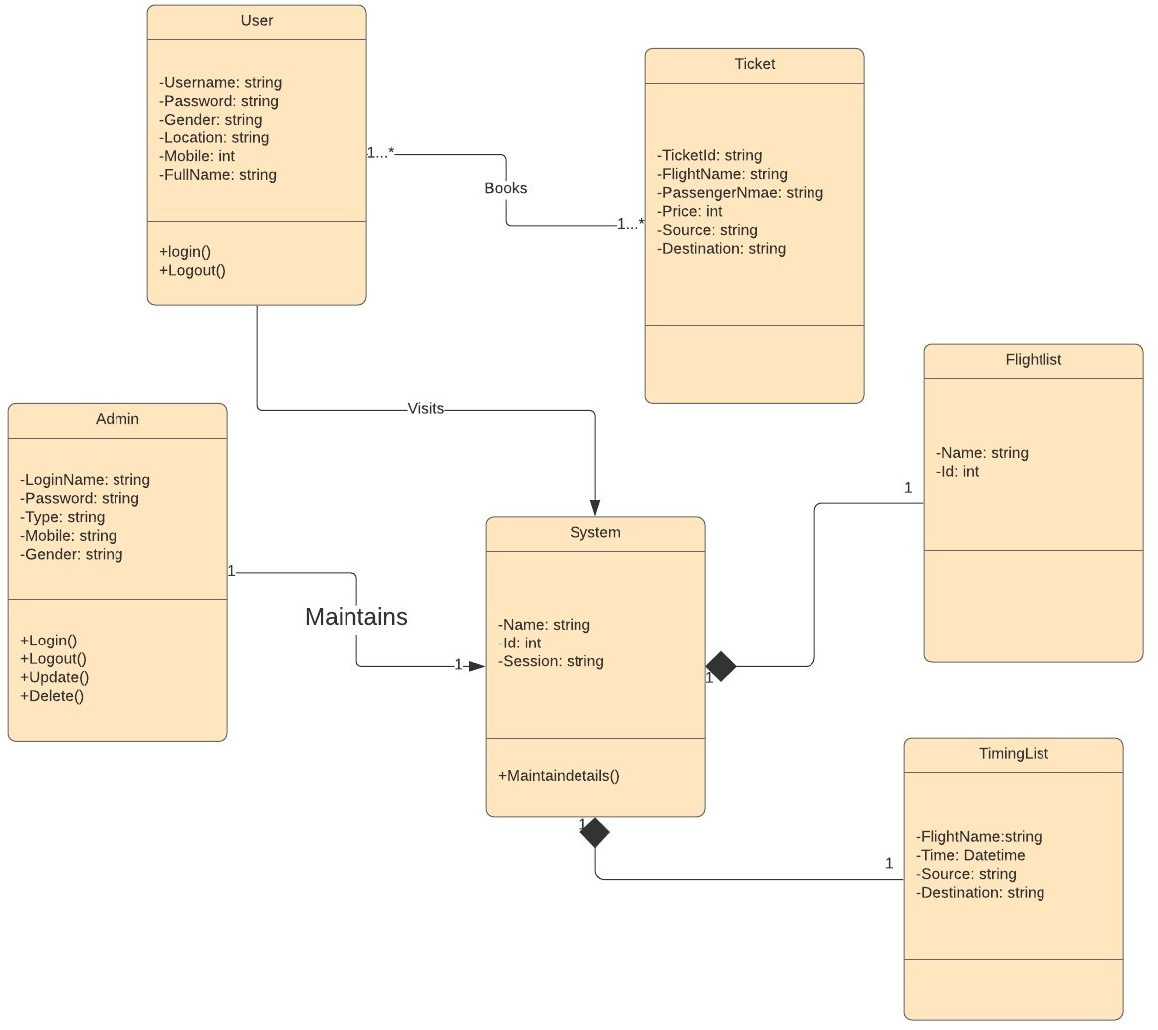

**Class Diagram**

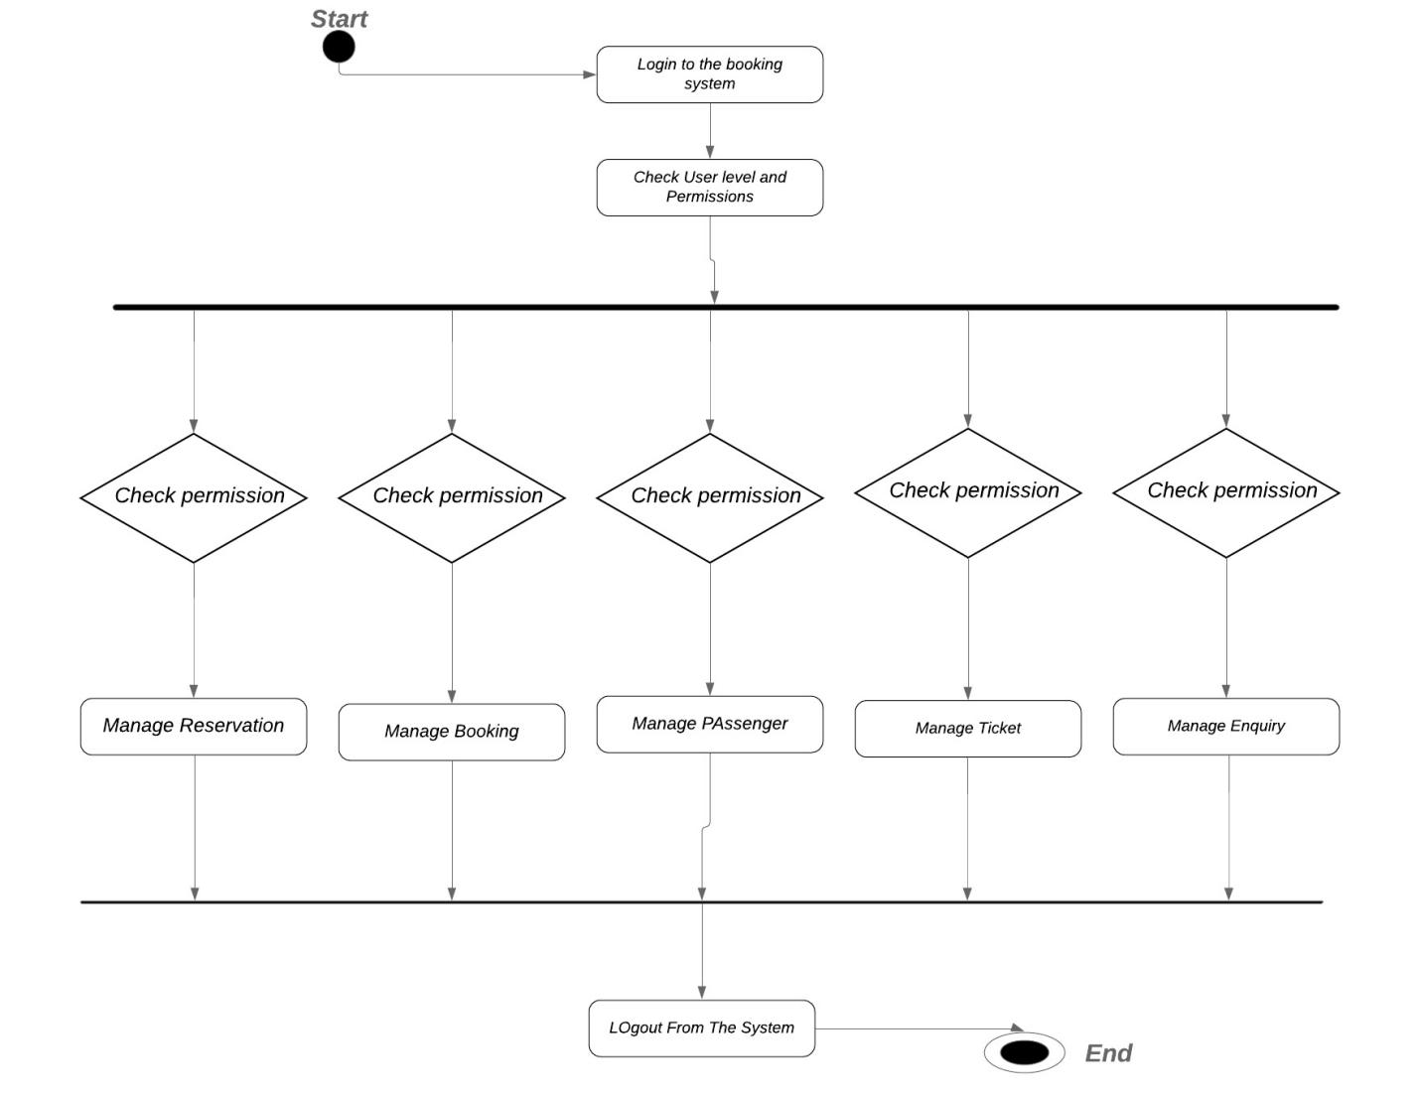

**Activity Diagram**

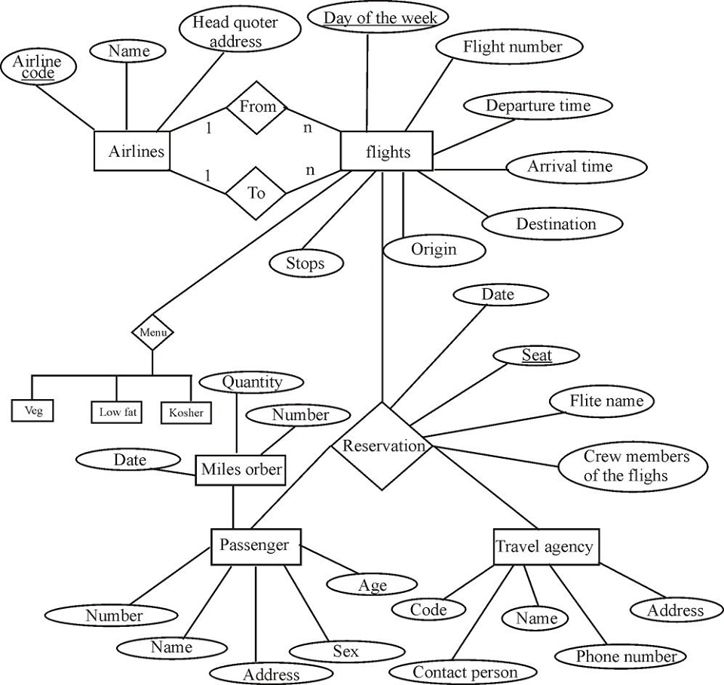

**E-R Diagram**

**Quality Gates**

The water fall model must complete each phrase before moving to the next phase, there is no scope for overlapping of phases in this development process. This will reduce the costly iterations among phases. The development team need to makes sure that certain criteria of the current phase have been met that will ensure the finished product. Backing is not possible for this system development

**Gate 1:** There will be a gate to pass through between each phases. Before moving on to the design phase from planning phase- deployment, confirming, and operation system must be checked.

**Gate 2:** Notify change in the system, confirming and signing with all related stakeholder, establishing a change control environment before going to the development phase.

**Gate 3:** All Regression tests pass, Schema verification against database design documentation, and data dictionary matches schema, validated against one another, all requirement changes must be traceable to the source. These things should be included before heading into the deployment.

**Gate 4:** Proper Documentation, customer accepting the product, all the success criteria checking includes before completing the project.

**Gate 5:**

|  |  |
| --- | --- |
| Work Product | SQA Method |
| Requirement Documents | Inspection of the document |
| Software development project management | Inspection |
| Design Documents | Spell checking of the documents |
| Schedule | Inspection |
| Code | Code Inspection |
| System Testing | Test Coverage Measurements |
| Alpha test | 5 weeks of testing at the developers site |
| Beta test | 5 weeks of testing at the client site |

**List of Task (Work Breakdown Structure)**

**Initiate Project**

1. **Develop Project Charted**
   * 1. Define Scope
     2. Define Requirements
     3. Identify High-Level Roles
     4. Develop High-Level Budget
     5. Identify High-Level Control Strategies
2. **Finalize Charter and Gain**
   * 1. Consolidate and publish project charter
     2. Hold review meeting
     3. Revise project charter
     4. Gain approvals from government
3. **Plan Project**
   * 1. Develop work plan
     2. Develop project staffing plan
     3. Develop project schedule
     4. Develop project budget
4. **Develop Project Control Plan**
   * 1. Develop communication plan
     2. Develop quality management plan
5. **Design**
   * 1. Define Stages and activities
     2. Design content Formats
     3. Object design Review
6. **Build**
   * 1. Write Code
     2. Project Review with Airline Agencies
7. **Testing**
   * 1. Unit Testing
     2. Test of Usability
8. **Implementation**
   * 1. Move tool to production environment
     2. Announce Tool Arability
9. **Close Project**

**Effort Estimation**

For estimation we used CoCoMo (Constructive Cost Model) II

Our Project is a Semi- Detached system for which Coefficient<effort factor. = 3.0

Complexity, P = 1.12; SLOC dependent coefficient, T = 0.35; SLOC = 20000

Effort, PM = Coefficient<effort factor> * (SLOC/1000) ^ P

= 3 * (20000/1000) ^ 1.20 = 109 person-month

Development Time, DM = 2.5 * (PM) ^ T = 2.5 * 109 ^ 0.35 = 13 months = 52 weeks

Required People, ST = PM/DM = 109/13 = 8.4 = 8 Persons

**Major Milestones**

|  |  |  |
| --- | --- | --- |
| **No.** | **Item** | **Milestone Date** |
| 1 | Planning | 20-08-2020 |
| 2 | Project Presentation | 30-08-2020 |
| 3 | Requirement Analysis | 20-09-2020 |
| 4 | Requirements review with airlines agency | 03-09-2019 |
| 5 | Preliminary Design | 08-10-2019 |
| 6 | Details Design | 09-10-2019 |
| 7 | Coding | 10-10-2019 |
| 8 | Internal Project Review | 20-09-2019 |
| 9 | Testing | 15-11-2019 |
| 10 | Demo Software | 20 -12-2019 |

**Scheduling the Tasks**

|  |  |  |  |
| --- | --- | --- | --- |
| **Task** | **Start Date** | **Duration (Days)** | **End Date** |
| **Initiate Project** | **01/07/2020** | **30** | **02/08/2020** |
| **Develop Project charter** | 01/07/2020 | 15 | 16/07/2020 |
| Define Scope | 01/07/2020 | 5 | 06/07/2020 |
| Identify High Level Roles | 05/07/2020 | 2 | 07/07/2020 |
| Develop High level Budget | 08/07/2020 | 2 | 10/07/2020 |
| Identify High level Control Strategies | 20/07/2020 | 6 | 26/07/2020 |
| **Finalize Charter and Gain Approval** | **02/08/2020** | **10** | **12/08/2020** |
| Consolidate and publish project charter | 02/08/2020 | 3 | 05/08/2020 |
| Hold Review Meeting | 07/08/2020 | 2 | 09/08/2020 |
| Revise Project Charter | 08/08/2020 | 3 | 11/08/2020 |
| Gain Approvals from Government | 10/08/2020 | 2 | 12/08/2020 |
| **Plan Project (10%)** | **14/08/2020** | **28** | **12/09/2020** |
| **Develop Work Plan** | 14/08/2020 | 12 | 26/08/2020 |
| Develop Work breakdown structure | 20/08/2020 | 4 | 24/08/2020 |
| Develop Project Staffing Plan | 25/08/2020 | 4 | 29/08/2020 |
| Develop Project Schedule | 01/09/2020 | 4 | 05/08/2020 |
| Develop Project Budget | 06/10/2020 | 4 | 10/08/2020 |
| **Develop Project Control Plan** | **12/09/2020** | **10** | **22/09/2020** |
| Develop Communication plan | 12/09/2020 | 6 | 18/09/2020 |
| Develop Quality Management Plan | 18/09/2020 | 4 | 22/09/2020 |
| **Design** | **24/09/2020** | **10** | **04/10/2020** |
| Define stages and activities | 24/09/2020 | 4 | 28/09/2020 |
| Design content formats | 26/09/2020 | 3 | 29/09/2020 |
| Object design review | 01/10/2020 | 3 | 04/10/2020 |
| **Build** | **05/10/2020** | **45** | **20/07/2020** |
| Write Code | 05/10/2020 | 35 | 10/11/2020 |
| Project review with Client | 10/11/2020 | 10 | 20/11/2020 |
| **Testing** | **20/11/2020** | **30** | **20/12/2020** |
| Unit testing | 21/11/2020 | 20 | 11/12/2020 |
| Test of usability | 10/12/2020 | 10 | 20/12/2020 |
| **Implementation** | **21/10/2020** | **40** | **10/10/2020** |
| Move tool to production environment | 21/11/2020 | 20 | 10/11/2020 |
| Announce Tool Arability | 19/12/2020 | 20 | 10/12/2020 |
| **Close Project** | **20/12/2020** | **25** | **20/12/2020** |

**Task Bar**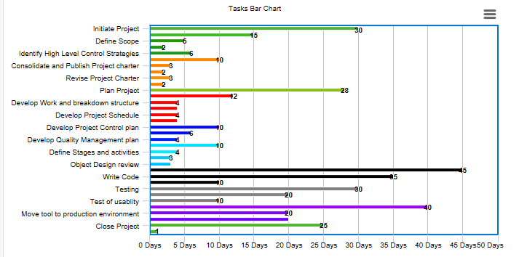

**Staffing Plan**

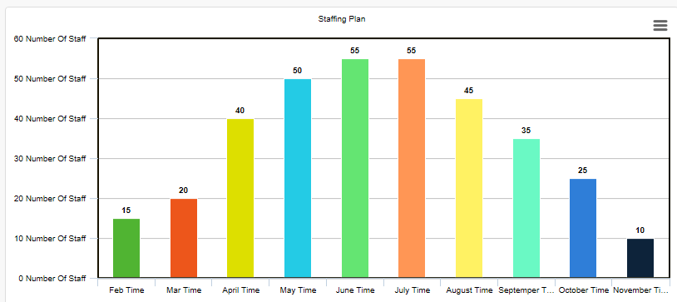

$\underline{Stack Holder registers :}$

|  |  |  |  |  |  |  |  |
| --- | --- | --- | --- | --- | --- | --- | --- |
| **Stake Holders** | **Designation** | **Department** | **Role in Project** | **Type of Communication** | **Expectation** | **Interest** | **Power** |
| A | CEO | Higher Management | Finance & oversee of the project | Weekly meetings with the project lead | Proper allocation of the budget in time. | High | High |
| B | Project team lead | Project department | Manage, monitoring, & Major role in M&C | Daily meetings with the project members | Completion of the project within time, scope & budget | High | High |
| C | Programming leader | Programming department | Program & plan the software’s layout & framework | Daily meetings with the project members | Completion of the project within time, scope & budget | High | Nominal |
| D | Database manager | Database department | Controlling database | Daily meetings with the project members | Completion of the project within time, scope & budget | High | Nominal |
| E | Document manager | Documentation department | M&C documentation & collaboration with legal department | Daily meetings with the project members | Completion of the project within time, scope & budget | High | Nominal |
| F | Procurement manager | Procurement department | Procure the software(visual basic) & Hardware’s | Written & verbal | Produce cheap & the best available | High | High |
| G | HRM | HR department | Hire the individuals for the project & defining their responsibilities. | Face-to-Face, Written | Hire the best people for the project | High | Nominal |
| H | Finance manager | Finance Department | Assists PM for cost & budget allocation | Face-to-Face | Helps to allot the budget in a possible minimum way for the project | High | High |
| I | Marketing manager | Marketing Department | Manage relationship between the company & client & Market the product after development | Face-to-Face, Written | To Market the product efficiently &effectively | High | Low |
| J | Quality manager | Quality Department | Check the quality of the product | Written, Verbal | Ensure the quality & progress | High | High |
| K | Software Testing members | Testing Department | Ensures that the ATRS software is up to the requirement. | Written | Proper inspection of the each & every part of the project | High | Low |

**Staffing plan:**

|  |  |  |
| --- | --- | --- |
| **Person** | **Designations (Responsibilities)** | **Backup** |
| Shebika Rani | Project Manager | Mr. Ahad Karim |
| Humaira Khondokar Gim | Technical Lead | Mr. Mushfiq |
| Mr. Mushfiq | Test Lead | Mr. Jawad Ahmed |
| Mr. Khaleel Ahmed | Requirements (Lead) | Mr. Anas Choudhury |
| Mr. Anas Choudhury | Requirements | Mr. Fahim Haque |
| Mr. Zakir Haque | System Design | Mr. Jalil Mahmood |
| Anamika Basak | System Desginer | Mr. Rahat Khan |
| Shebika Rani | Programmer (Lead) | Mr. Bahar Ahmed |
| Mr. Bahar Ahmed | Programmer | Mr. Kawsar |
| Mr. Awal | Verification Engineer | Mr. Awab |
| Humaira Khondokar Gim | Database Engineer | Mr. Akib |
| Mr. Omar | Configuration Manager | Mr. Salman Rahman |
| Mr. Shumon | Quality Analyst | Mr. Akram |
| Mr. Sakib | Installation Specialist | Mr. Ahmed |

**Data Dictionary:**

Account Info:

|  |  |  |  |  |  |
| --- | --- | --- | --- | --- | --- |
| Sl No | Attributes | Data Types | Field Length | Constraints | Descriptions |
| 1 | User name | Alpha-numeric | 20 | Primary key | A unique identity for each user |
| 2 | Password | Alpha-numeric | 20 | Not Null | Password of the user for the secure account |
| 3 | First name | String | 20 | Not Null | First name of the user |
| 4 | Last name | String | 20 | Not Null | Last name of the user |
| 5 | Gender | Character | 5 | Not Null | Gender of the user. |
| 6 | Contact no | Numeric | 20 | Not Null | Contact number of the passenger |
| 7 | E-Mail Id | Alpha numeric | 20 | - | Email id of the user |

Reservations

|  |  |  |  |  |  |
| --- | --- | --- | --- | --- | --- |
| Sl No | Attributes | Data Types | Field Length | Constraints | Descriptions |
| 1 | E-Ticket number | Numeric | 10 | Primary key, Foreign key | unique ticket number generated at the time of reservation |

Passenger Info

|  |  |  |  |  |  |
| --- | --- | --- | --- | --- | --- |
| Sl No | Attributes | Data Types | Field Length | Constraints | Descriptions |
| 1 | Ticket number | Numeric | 20 | Primary key | unique ticket number generated at the time of reservation |
| 2 | First name | String | 20 | Not Null | First name of the passenger |
| 3 | Last name | String | 20 | Not Null | Last name of the passenger |
| 4 | Gender | Character | 5 | Not Null | Gender of the passenger |
| 5 | DOB | Numeric | 20 | Not Null | Death of birth of the passenger |
| 6 | Booking User name | Alpha Numeric | 20 | Foreign key | Unique user name under which reservations(S) were made |
| 7 | Flight number | Alpha numeric | 10 | Foreign key | Unique Id/no of a particular flight |
| 8 | Seat number | Integer | 3 | Not Null | Specific number for identity of every seat |
| 9 | Departure date | Numeric | 20 | Not Null | Date of departure of the flight |
| 10 | E-contact | Numeric | 20 | Not null | Emergency contact number of the passenger. |

Bus Info

|  |  |  |  |  |  |
| --- | --- | --- | --- | --- | --- |
| Sl No | Attributes | Data Types | Field Length | Constraints | Descriptions |
| 1 | Bus number | Alpha Numeric | 10 | Primary key | unique Id/no. of a particular flight |
| 2 | Origin | String | 20 | Not Null | Place from bus will depart |
| 3 | Destination | String | 20 | Not Null | Place where bus will reach |
| 4 | Total seats | Numeric | 5 | Not Null | Total seat in a particular bus |
| 5 | Days | String | 10 | Not Null | Days when bus will departs |

Web-check-In

|  |  |  |  |  |  |
| --- | --- | --- | --- | --- | --- |
| Sl No | Attributes | Data Types | Field Length | Constraints | Descriptions |
| 1 | E-Ticket number | Numeric | 10 | Primary key, Foreign key | unique ticket number generated at the time of reservation |

Cancellation

|  |  |  |  |  |  |
| --- | --- | --- | --- | --- | --- |
| Sl No | Attributes | Data Types | Field Length | Constraints | Descriptions |
| 1 | E-Ticket number | Numeric | 10 | Primary key, Foreign key | unique ticket number generated at the time of reservation |
| 2 | refund | Integer | 10 | - | Amount refunded (if any) to user |

Payments Info

|  |  |  |  |  |  |
| --- | --- | --- | --- | --- | --- |
| Sl No | Attributes | Data Types | Field Length | Constraints | Descriptions |
| 1 | Transection Id | Alpha Numeric | 20 | Primary key | unique Id generated at the time of payment |
| 2 | Booking User name | Alpha Numeric | 20 | Foreign key | Unique user name under which reservations were made |
| 3 | Total fare generated | Integer | 10 | Not null | Total price of the reservations made |

Flight Status

|  |  |  |  |  |  |
| --- | --- | --- | --- | --- | --- |
| Sl No | Attributes | Data Types | Field Length | Constraints | Descriptions |
| 1 | Bus number | Alpha Numeric | 10 | Primary key, Foreign key | Unique Id/no of a particular bus |
| 2 | Departure date | Numeric | 20 | Primary key | Date of the departure of the bus |
| 3 | Arrival Date | Numeric | 20 | Not Null | Date of the arrival of the bus |
| 4 | Scheduled departure time | timestamp | 10 | Not Null | Time when the bus is scheduled to depart |
| 5 | Scheduled Arrival time | timestamp | 10 | Not Null | Time when the bus is scheduled to arrive |
| 6 | Estimated/actual departure time | timestamp | 10 | Foreign key | Time when the bus is estimated to depart |
| 7 | Estimated/actual Arrival time | timestamp | 10 | Foreign key | Time when the bus is estimated to arrieved |
| 8 | Status | string | 30 | Not Null | Status of the bus |

**Monitoring and Control:** The Process of Monitoring and control process views the overall tasks and metrics necessary to ensure that the approved and authorized project is within scope, within schedule, and on allocated budget so that the process proceeds with minimal risks. This process involves comparing actual performance with planned performance. Monitoring and Controlling process is performed continuously throughout the project. The following is a checklist of items to consider

* Every Week Status Meeting will be conducted.
* Every Week the objective met will be checked with their actual completion date and planned completion date
* Implement Strategies to protect the project from scope change requests
* Approach to monitor spending against the project budget and progress against planned schedule.
* The Internal and External reports to be generated by specific departments about their progress
* The risk checklists that will be used to identify, analyze, prioritize, monitor and mitigate risks.
* Weekly Meet up Stakeholders to resolve disagreements with the customer, including how to handle schedule slips
* Process Re-Engineering to improve efficiency and effectiveness
* Use the Earned Value Analysis (EVA) to measure the progress of the project quantatively

**Risk Information Sheet**

|  |  |  |  |
| --- | --- | --- | --- |
| **Risk ID** | **Description** | **Probability** | **Impact** |
| Risk_ID_1 | Software team doesn’t have good experience in distributed Database Management System | 70% | Medium |
| Risk_ID_2 | Technology will not meet expectation | 60% | Medium |
| Risk_ID_3 | Stuff turnover will be high | 50% | Medium |
| Risk_ID_4 | Customer will change Requirement | 80% | Critical |
| Risk_ID_5 | Project will outrun the allocated Budget | 70% | Catastrophic |

|  |  |  |  |  |
| --- | --- | --- | --- | --- |
| |  |  |  |  | | --- | --- | --- | --- | | Risk_ID_1 | Date: 01/04/20 | Probability: 70% | Impact: Medium |   Description: Software team doesn’t have enough experience  Mitigation plan: Organize a 5 day training program and build a prototype database  Monitoring and Management: Track progress of the developers on weekly basis until the team has confidently tested the prototype  Status: Initial Identification |
| |  |  |  |  | | --- | --- | --- | --- | | Risk_ID_3 | Date: 10/06/2018 | Probability: 50% | Impact: Medium |   Description: More staff leaving the job  Mitigation Plan: Make sure that tasks are equally divided between the available staff, so that no one has overload of work  Monitoring and Management: Keep an close on the emotions of the employee and their concentration on the work, how much effort they are putting in it  Status: Initial Identification | |

|  |  |  |  |  |
| --- | --- | --- | --- | --- |
| |  |  |  |  | | --- | --- | --- | --- | | Risk_ID_5 | Date: 25/10/2018 | Probability: 70% | Impact: Catastrophic |   Description: Budget running low before the end of final deliverables  Mitigation plan: Make a plan to keep the spending within check, not trying not to spend too much on technologies that add no extra value to the outcome of the project.  Monitoring and Management: Keep the amount left in hand on regular checks as well as make sure no extra bucks are being spent on gold plating |

**List of Deliverables**

|  |  |  |
| --- | --- | --- |
| **No** | **Item Description** | **Date** |
| 1 | Software Requirements specification document | 30-02-2019 |
| 2 | Design Documents | 15-03-2019 |
| 3 | Considering Business rules | 30-03-2019 |
| 4 | Defining Quality requirements | 10-04-2019 |
| 5 | Alpha Version | 15-05-2019 |
| 6 | Beta Version | 05-06-2019 |
| 7 | User Manuel | 30-06-2019 |
| 8 | Installation Manuel | 15-07-2019 |
| 9 | Maintenance guide | 30-07-2019 |
| 10 | Agreeing on terms of Service | 01-08-2019 |

**Defect Tracking Process:** The more focused process and testing will allow the software to be less buggy. Defect Tracking is much more efficient and effective in reducing the number of defects and also is very cost effective to fix the defects found during the early stage of the software process. To track the defects some precautionary steps are describe below.

* Identify the critical defects
* Early detection of the defect
* Estimate expected impact
* Minimize Expected Impact
* Use Tracking tools to track Defects.
* A web based database will be maintained to track the defects
* Unit testing and regression testing will be added to the combined code base.
* The whole execution operation is broken down into several parts to track down defects more easily

**Metrics**

Actual completion of Project: The actual time the project was completed on.

Total number of defects found: Aggregated the number of defects per requirements

Productivity: how many simple tasks can be delivered on a single day.

Number of files: The total number of file that encompasses the software

Time spent of system identification testing: Actual time spent in identifying the testing to be done on the software

Line of codes produced per week: How much of coding was done per week by the development team

**Post Mort-em:** The Main expected outcome from the project is to make sure that the end users can get a user friendly environment from the software. To achieve this, the software has to be made with much care, to create a successful software the board must arrange regular meeting with the development team to make sure the project scope is being kept under control. The development process used for the development was the waterfall process model as all of our requirements were well known. Many of the challenges that we went through in development phase was handled with care by our Manager and Business Analyst. We hope the final software will meet the user requirements and make it easy for everyone to use it.